**Connectivity Components:**

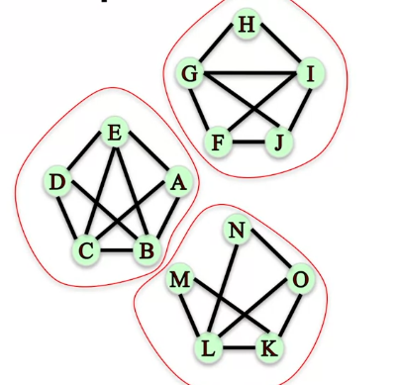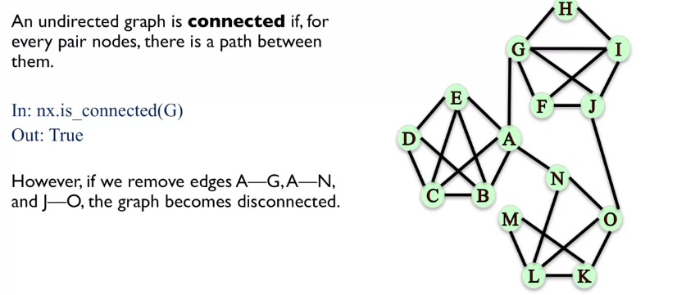Here we’re talking about connectivity in **undirected graphs**.

We can see that by removing these nodes we end up with communities that have no common connections, and that they are closed off communities.

**Example:**

Here a path is any length path connecting nodes, not just a direct connection.

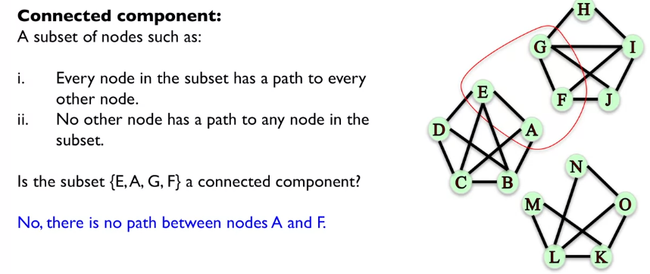

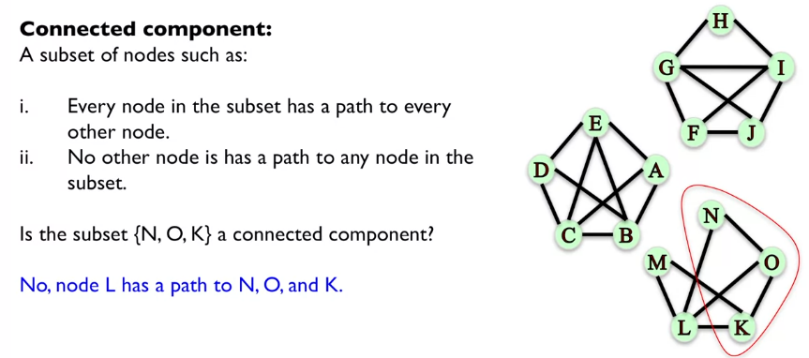

Who do we use **NetworkX** to determine which nodes form **connected components**? We could also return the component that a particular node belongs to.

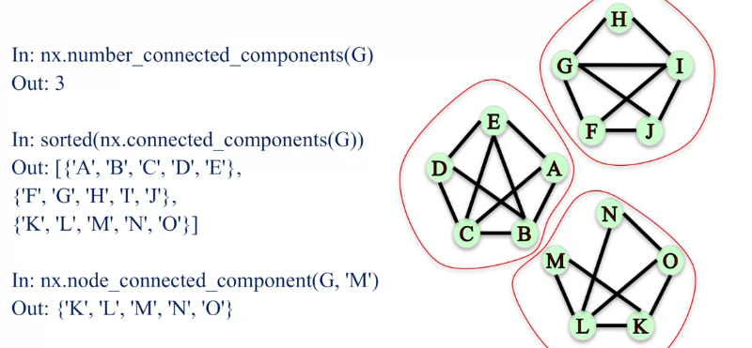

**Connectivity in Directed Graphs:**

Where G is the entire network: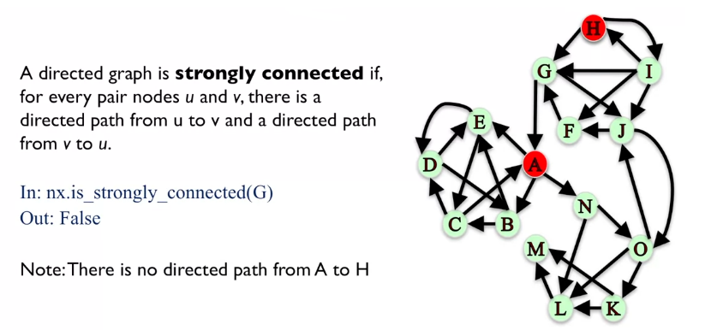

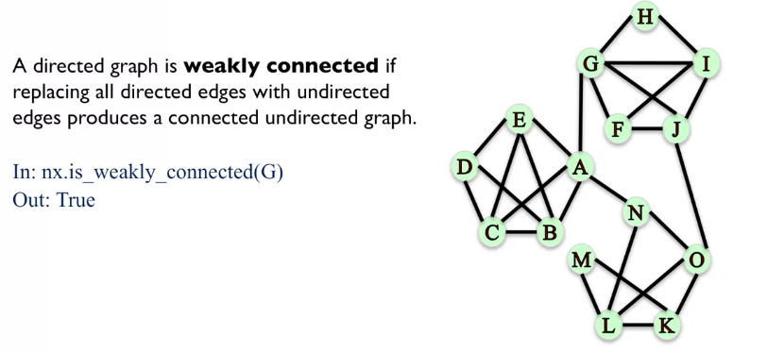

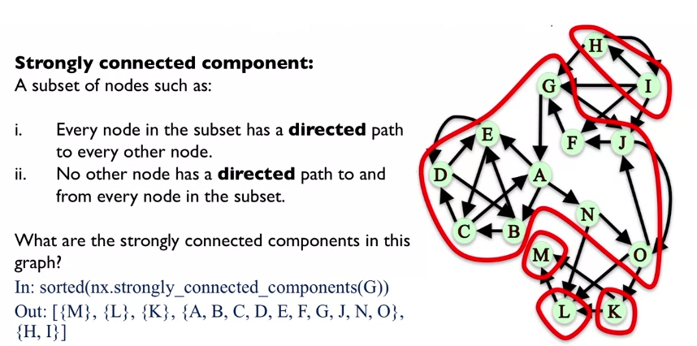

M, L and K are returned as these are the only remaining sets that are not included in the strongly connected component sets, however, all nodes are strongly connected to themselves, so they are still present.

